|  |
| --- |
| FAST National University |
| **Introduction to DOSBox**  **Lab 1** |
|  |

**Computer Organization and Assembly Language**

|  |  |
| --- | --- |
| **Student Name** | Muhammad Ahmad |
| **Registration #** | 21L-5617 |
| **Instructor** | Hazoor Ahmad |
| **Class** | DS |
| **Section** | A1, A2, D1, D2 |
| **Semester** | Fall 2022 |

Fast School of Computing

FAST-NU, Lahore, Pakistan

# Activity 1

## **Assembly Language Code**

[[org 0x0100]

jmp start

num: dw 12,25,10

start:

mov ax,0x25;PART A

mov bx,0x10

mov cx,ax

mov ax,bx

mov bx,cx

mov cx,[0x270]

mov ax,[num]

mov ax,[num+2]

mov ax,[num+4]

mov ax,0x4c00

int 21

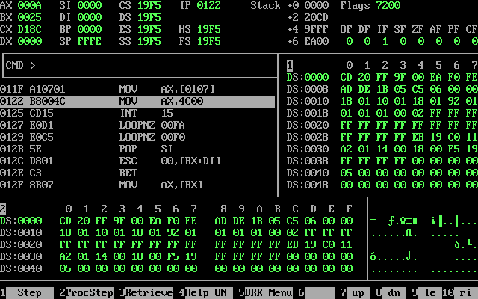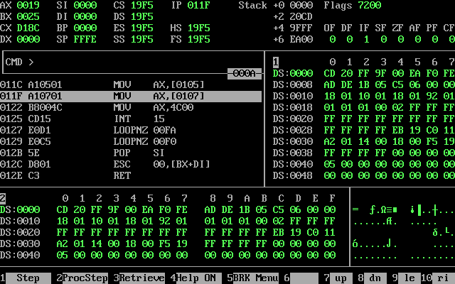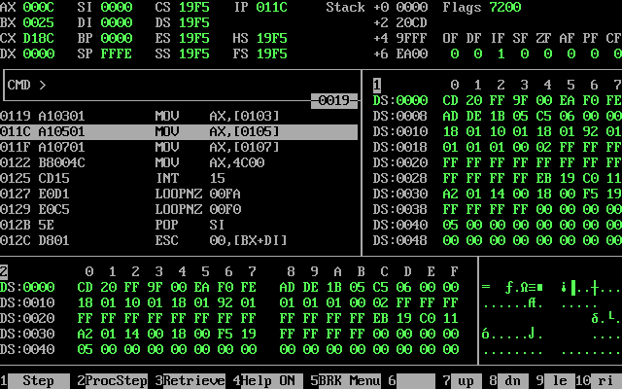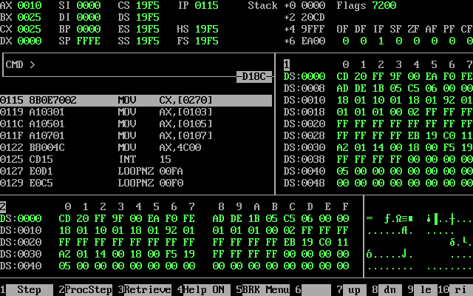

# Activity 2

## **Assembly Language Code**

[org 0x0100]

jmp start

n1:dw 10

n2: dw 20

n3: dw 30

n4: dw 40

n5:dw 50

sum:dw 0

n : dw 10,20,30,40,50

sum1: dw 0

start:

mov ax,[n1]

add [sum],ax

mov ax,[n2]

add [sum],ax

mov ax,[n3]

add [sum],ax

mov ax,[n4]

add [sum],ax

mov ax,[n5]

add [sum],ax

mov ax,[sum]

mov si,0

mov cx,5

l1:

mov bx,[n+si]

add [sum1],bx

mov bx,[sum1]

add si,2

sub cx,1

cmp cx,0

jnz l1

mov bx,[sum1]

mov ax,0x4c00

int 21

## **Debugging Screenshots**

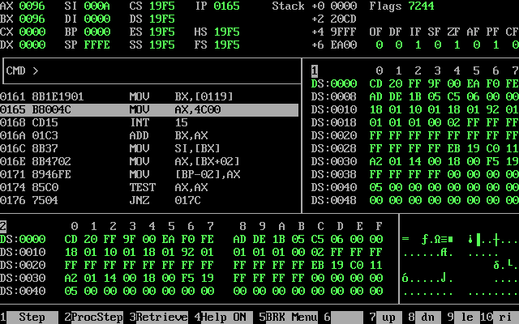

# Activity 3

## **Assembly Language Code**

[[org 0x0100]

jmp start

start:

mov ax,0x200

mov bx,0x150

mov byte [250], 0x50

mov byte [200],0x25

mov cx,[250]

MOV DX,[200]

mov bx,200

mov cx,[250]

mov ax, [bx]

mov ax,0x4c00

int 21

## **Debugging Screenshots**

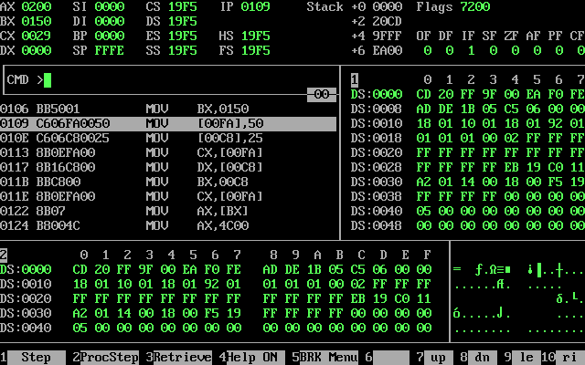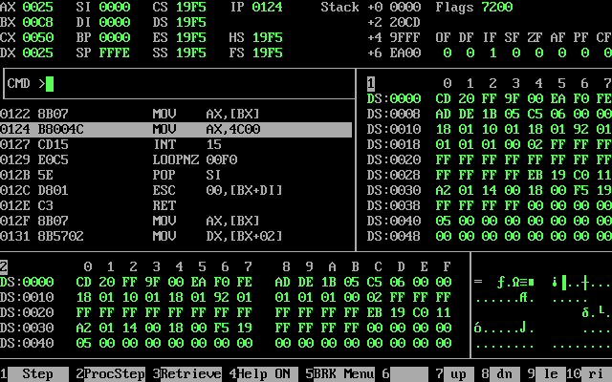

# Activity 4

## **Assembly Language Code**

[org 0x0100]

jmp start

Array: dw 111, 999, 888, 888, 11, 99, 88, 88, 1, 9, 8, 8

sum:dw 0

start:

mov si,0;

mov bx,12

l1:

mov ax,[Array+si]

add [sum],ax

add si,2

sub bx,1

CMP bx,0

jnz l1

mov ax,[sum]

mov ax,0x4c00

int 21

## **Debugging Screenshots**

